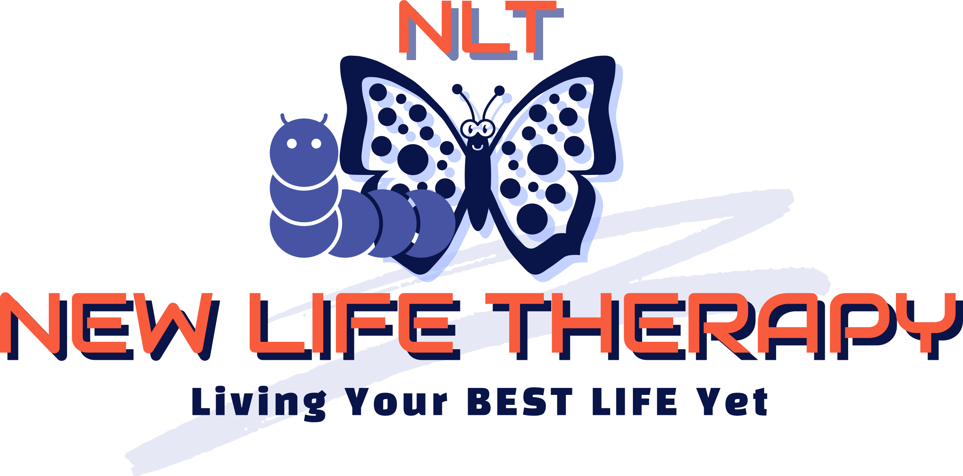
Privacy Notice

- New Life Therapy is a counselling service that is owned and managed by the sole trader, Sherene Charles who is the data controller of personal information for the purposes of the General Data Protection Regulation (GDPR) and the Data Protection Act 2018. Sherene has the responsibility of deciding how your personal data is processed.

- Sherene is required by professional standards to have a professional clinical supervisor for work. No identifiable information is shared with the Supervisor. Both Sherene and her Supervisor are members of a Professional Association with an enforceable code of ethics.

- Sherene will only share your personal information you have given her if there is:

- an immediate risk of substantial harm to you or others, or serious
criminal activity;
- a legal requirement - terrorism, drug money laundering and drug trafficking are
examples;
- due legal process, e.g. a Court Order;

How your records will be stored is as follows:

- normally three years from the end of working with you this may be longer if you and Sherene both agree - if so you will be asked to sign a new consent form
- HMRC requires Sherene to keep accounts information for six years, plus the current tax year, so up to seven in total.

The rights you have under Data Protection law:

- to access a copy of your records and have an explanation of your
personal data;
2. to request correction or erasure;
- in certain circumstances to request limiting or ceasing data processing.

